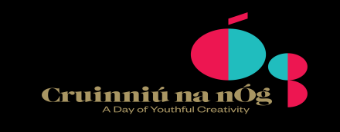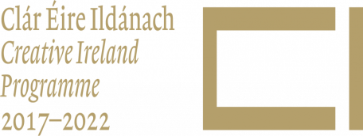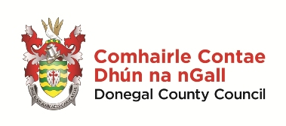

Cruinniú na nÓg Saturday 23 June 2018 - Proposal

1. Contact Details
Name |  | Organisation
Address including eircode |  | Mobile
 |  | Landline
 |  | Email
 |  | Website

2. Event - Describe the proposed event and how it meets the objective of doing, making, creating.

3. Capacity – State capacity/expertise including details of similar work and scale undertaken in recent years.

3. Location – State the location of the proposed event. A visit the venue in advance of making a proposal is highly recommended.

Bundoran Library (10.00 – 2.30) Buncrana Library (10.00 – 2.30)

Letterkenny Library (10.00 – 2.30) Carndonagh Library (10.00 – 2.30)

Milford Library (10.00 – 2.30) Regional Cultural Centre (1.00 – 5.00)

Leabharlann Phobail na Rosann (10.00 – 2.30) County Museum (1.00 – 4.30)

Other (please specify location and note the Council must be indemnified on the organisation/venue’s insurance policy with written evidence to be provided)

5. Audience
Proposed age range and/or Family event (children and parents attending together) |  | Language the event will be delivered in
Estimated number of attendees

6. Cost. Please include breakdown including fees, materials etc.

Total cost of the proposed event | €

NB Tax and bank details will have to be provided by the organisers of events selected. It is not necessary to include these details now but do ensure all is in order before applying.

7. Declaration, name and signature
I declare the above information is true to the best of my knowledge and belief.
I undertake to keep accurate records and understand vouched expenditure (original) must be provided.
I confirm detailed breakdown of costs is included.
I understand approved events may be subject to audit/site visit.
I understand a risk assessment will be undertaken and will comply with Health & Safety requirements.
I confirm awareness of obligations in relation to Child Protection and will comply with/provide evidence of Garda Vetting and/or Child Protection Policy as appropriate.
I confirm the Department of Culture, Heritage and the Gaeltacht, the Creative Ireland Programme and Donegal County Council will be acknowledged in any publicity.

Name of contact person
Signature
CLOSING DATE: 12 NOON, 16TH mAY 2018

